IB Internal Assessment

[Title]

By [Insert Name]

Contents | Page no.
1.0 Field work and Geographic Context ……………………………………… | [1]
2.0 Method of investigation …...………………………………………………. | [1]
3.0 Research Findings ..………………………………………………………… | [1]
4.0 Conclusion …………………………………………………………………… | [1]
5.0 Evaluation ……………………………………………………………………. | [1]
6.0 Bibliography …..……………………………………………………………... | [1]

STYLE TIPS
* Delete this page from your final Draft *
Delete all the blue writing from your final draft
Start each new section on a new page

Maps
- Remember all maps should have BOLTS.
- Produce your own maps with Google maps or hand draw where possible.

Photos
- Remember all photos should have a comment below them.
- It is important to refer to photos in your text… if you can’t, is it relevant?

Tables
- Remember all tables should have a heading and clearly summarise information.

Graphs
- Remember all graphs should have a title
- It is important to refer to graphs in your text… if you can’t, is it relevant?
- Do not have graphs with only two items e.g.

Each graph needs to numbered, labelled, presented and then a very brief comment. A textbox is the best way to do this.
Graph 1. Temperatures taken at the Quad pond and from the BOM
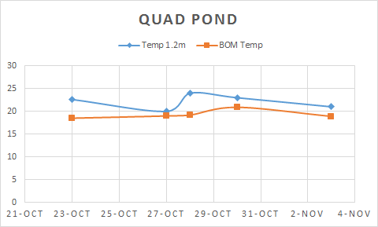

The graph shows that the air temperature at Quad Pond water fluctuates more than the Sydney mean air temperature.

1.0 Fieldwork and Geographic Context (300 words)
[The fieldwork question (the precise inquiry) guides the fieldwork investigation. It must be narrowly focused, appropriate and stated as a question that can be answered through the collection of primary information in the field. (Where appropriate, students can make a brief preliminary judgment or prediction answering the fieldwork question. This prediction may be formulated as a hypothesis.)
Students must also comment briefly on the geographic context, explaining why and where the fieldwork investigation is to be carried out. This can include relevant spatial, physical, socio-economic conditions and other background information, concepts or characteristics. A map of the research area and/or the locations used in the fieldwork investigation is essential to provide the necessary spatial element.
Students must also state the area(s) of the syllabus to which the study relates, whether it is from the topic or development columns within the core, the optional themes or HL extension. It can be drawn from a combination of two or more topics or themes.]

1.1 Focus Question(s):

1.2 Geographic context and relation to syllabus:

1.3 Fieldwork plan:

3.0 Method of Investigation (300 words)
[Students must describe the method(s) used to collect information. The description may include sampling techniques, time, location and circumstances of information collection where relevant.
The method(s) used must be justified and must enable a sufficient quality and quantity of primary data to be produced to allow the fieldwork question to be investigated.]

4.0 Research Findings (1400 words)
[Students should treat and display the information collected using the most appropriate techniques. These techniques must be the most effective way of representing the type of information collected and must be well used. The precise techniques employed will differ depending on the nature of the fieldwork question but may include statistical tests (including confidence limits), graphs, diagrams, maps, annotated photographs and images, matrices and field sketches.
In the written analysis, students must demonstrate their knowledge and understanding of the fieldwork investigation by interpreting and explaining the information they have collected in relation to the fieldwork question. This includes recognizing any trends and spatial patterns found in the information collected.
Where appropriate, an attempt should be made to identify and explain any anomalies. Students must also refer to the geographic context, information collected and the ways in which the material
has been treated and presented. The treatment and display of material and the written analysis must be integrated within this section.]

5.0 Conclusion (200 words)
[Students should summarize the findings of the fieldwork investigation. There should be a clear, concise statement answering the fieldwork question. It is acceptable for the conclusion to state that the findings do not match the student’s preliminary judgment or prediction.]

6.0 Evaluation (300 words)
[Students should review their investigative methodology, including methods of collecting primary information. Within this, they should consider any factors that may have affected the validity of the data, including personal bias and unpredicted external circumstances such as the weather.
Students should suggest specific and plausible ways in which the study might have been improved and could be extended in the future.]

7.0 Bibliography (N/A Word Count)
[Not included in word count. an alphabetical listing of all information and graphic sources used. https://www.library.usyd.edu.au/subjects/downloads/citation/Harvard_Complete.pdf ]

